6SENG002W Concurrent Programming

FSP Process Composition Analysis & Design Form

Name | Tharindu De Silva
Student ID | W1761890/2018367
Date | January 2023

1. FSP Composition Process Attributes

Attribute | Value
Name | PRINTING_SYSTEM
Description | This is a composite process model of a printing system. It includes two student process and a technician process.
Alphabet  (Use LTSA's compressed notation, if alphabet is large.) | {{s2, s3}.{acquirePrint, acquireRefill, print, refill, release}, t.{acquirePrint, acquireRefill, print, refill, release, wait}}
Sub-processes  (List them.) | PRINTER, s1: STUDENT, s2: STUDENT, TECHNICIAN
Number of States | 55
Deadlocks  (yes/no) | No
Deadlock Trace(s)  (If applicable) | Not applicable

2. FSP "main" Program Code

The code for the parallel composition of all of the sub-processes and the definitions of any constants, ranges & process labelling sets used. (Do not include the code for the other sub-processes.)

FSP Program:
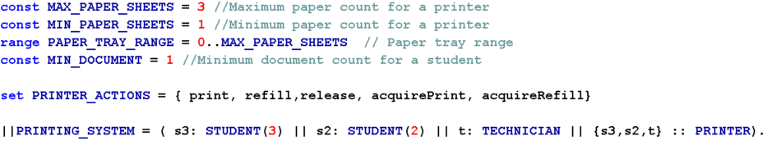

3. Combined Sub-processes
(Add rows as necessary.)

Process | Description
s1: STUDENT | This sub-process is to model the behaviour of a student who uses the printer to print documents. This instance of a student process is wished to print 3 documents.
s2: STUDENT | This sub-process is to model the behaviour of a student who uses the printer to print documents. This instance of a student process is wished to print 3 documents.
TECHNICIAN | This sub-process models the behaviour of a technician who refills the printer with paper when it needs to be refilled.
PRINTER | This sub process models the behaviour of the printer.

4. Analysis of Combined Process Actions

- Synchronous actions are performed by at least two sub-process in the combination.
- Blocked Synchronous actions cannot be performed, since at least one of the sub-processes cannot preform them, because they were added to their alphabet using alphabet extension.
- Asynchronous actions are preformed independently by a single sub-process.

Group actions together if appropriate, for example if they include indexes,
e.g. in[0], in[1], …, in[5] as in[1..5].

(Add rows as necessary.)

Synchronous Actions | Synchronised by Sub-Processes (List)
s2.acquirePrint, s3.acquirePrint  s2.print, s3.print | STUDENT, PRINTER
s3.release, s2.release, t.release | TECHNICIAN, STUDENT, PRINTER
t.acquireRefil, t.refill | TECHNICIAN, PRINTER

Blocked Synchronous Actions | Synchronizing Sub process (List) | Blocking sub-process
s3.acquireRefil, s3.refill,  s2.acuireRefill, s2.refill | STUDENT, PRINTER | STUDENT
t.acquirePrint, t.print | TECHNICIAN, PRINTER | TECHNICIAN

Sub-Process | Asynchronous Actions (List)
STUDENT | Not applicable
PRINTER | Not applicable
TECHNICIAN | t.wait

5. Parallel Composition Structure Diagram

The structure diagram for the parallel composition.

